Java nested try block->

The try block within a try block is known as nested try block in java.

Why use nested try block->

Sometimes a situation may arise where a part of a block may cause one error and the entire block itself may cause another error.

In such cases, exception handlers have to be nested.

Syntex->

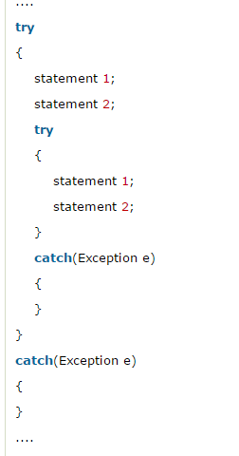

## **Java nested try example->**

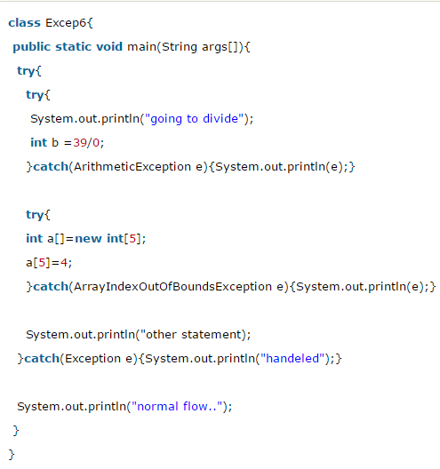

# **Java finally block->**

**Java finally block** is a block that is used to execute important code such as closing connection, stream etc.

Java finally block is always executed whether exception is handled or not.

Java finally block follows try or catch block.

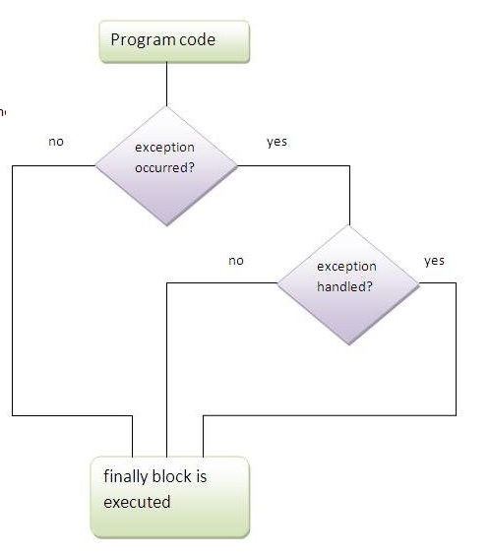

#### Note: If you don't handle exception, before terminating the program, JVM executes finally block(if any).

## **Why use java finally->**

* Finally block in java can be used to put "cleanup" code such as closing a file, closing connection etc.

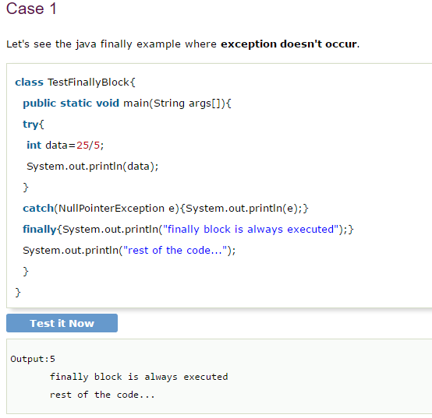

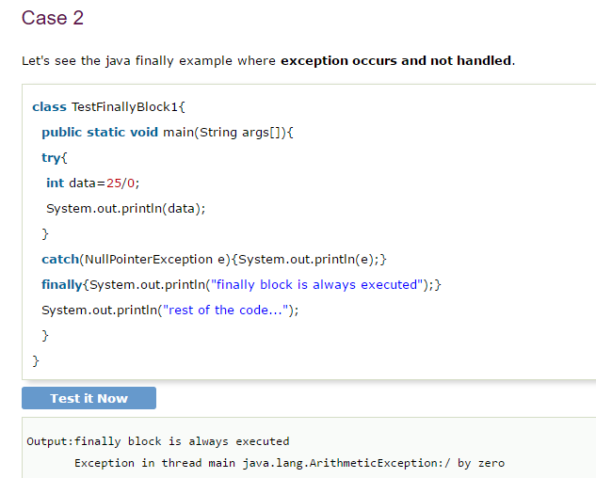

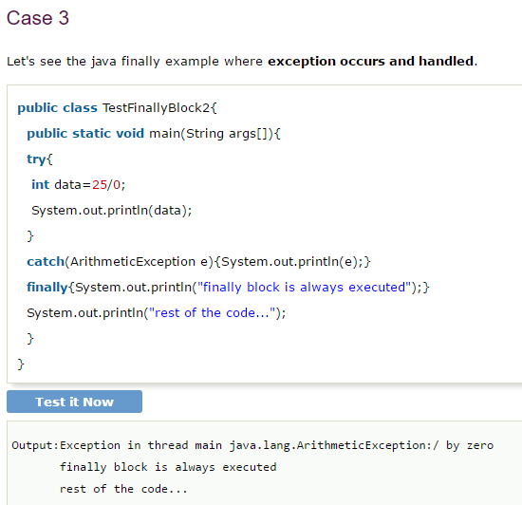

#### Rule: For each try block there can be zero or more catch blocks, but only one finally block.

#### Note: The finally block will not be executed if program exits(either by calling System.exit() or by causing a fatal error that causes the process to abort).